Assignment-1

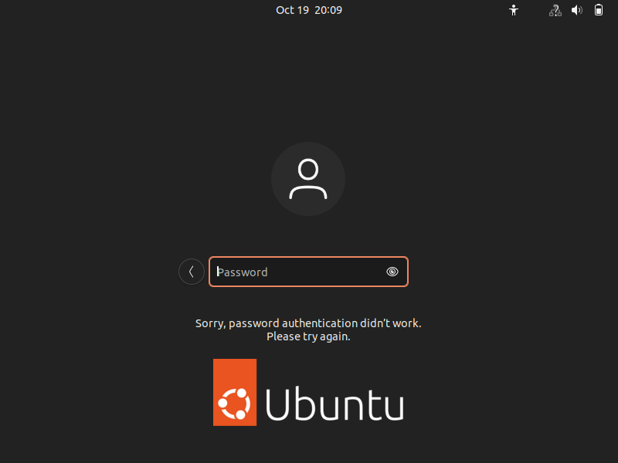

After trying to login with non-existent username it will terminate to password option after entering the password again it will terminate to the page where we cant access while it is showing like sorry your password authentication didn’t work please try again.

Assignment-2

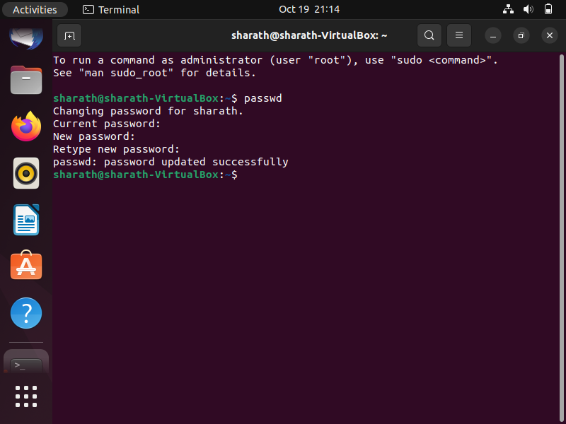

After changing password to IneuROn#42 the password updated successfully

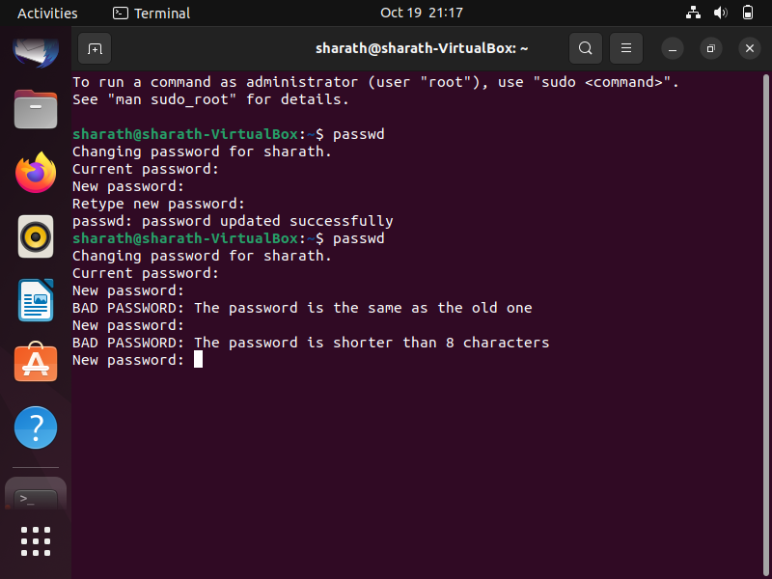

After the changing of password. again I have tried to change the password to 1234 but it thrown a error of the password characters are less .

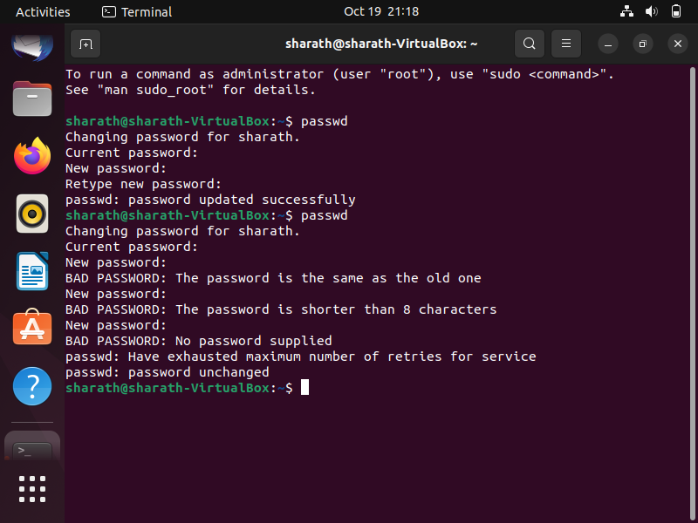

After trying to change the password with empty or null value it shown like no password supplied

Assignment -3

Using of the cd/ and then ls commands in the command line to change the directory and list the files in it but it as shown like no such files or directory present

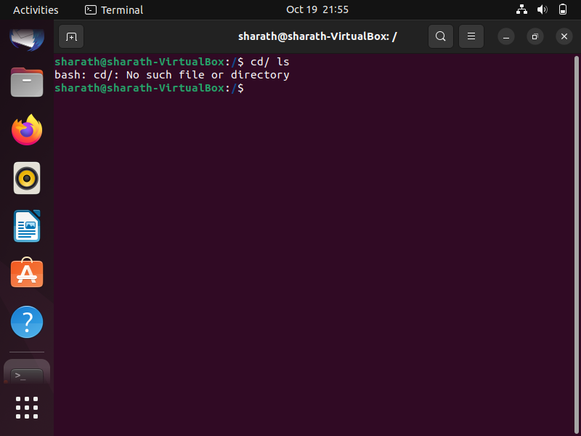

After entering the cd /home command the home directory will be created and after entering the ls command it will show the files which are in the 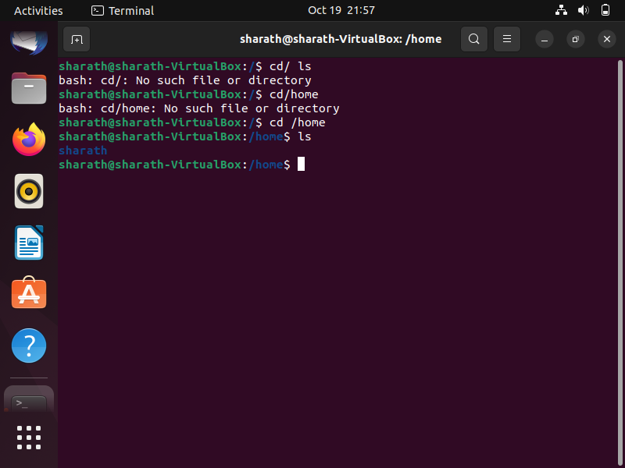

After entering the cd .. command it will moves to the previous directory 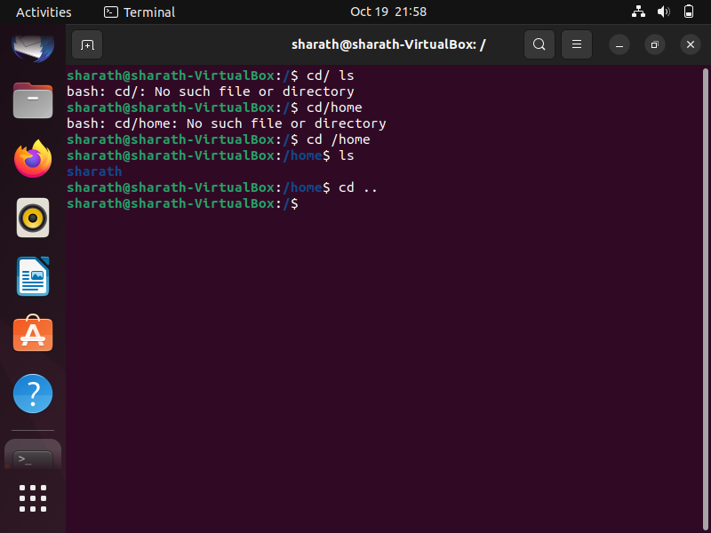

Now entering the cd /var/www/html and cd command in the prompt in the command line it shows that too many arguments are passed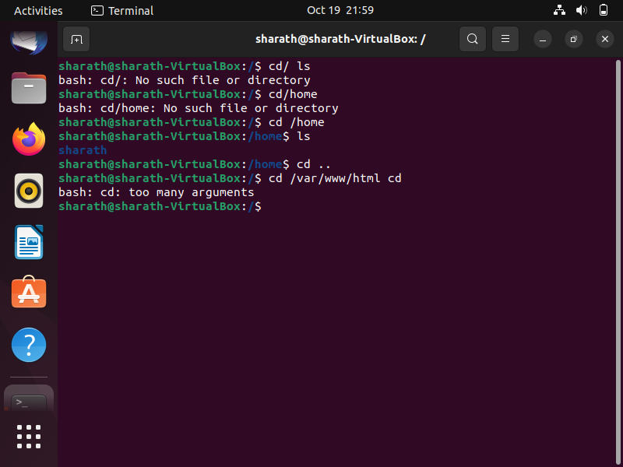

After passing the cd /root command and ls command in the command line it showed first us like permission denied and after using the ls command it will list the files and directories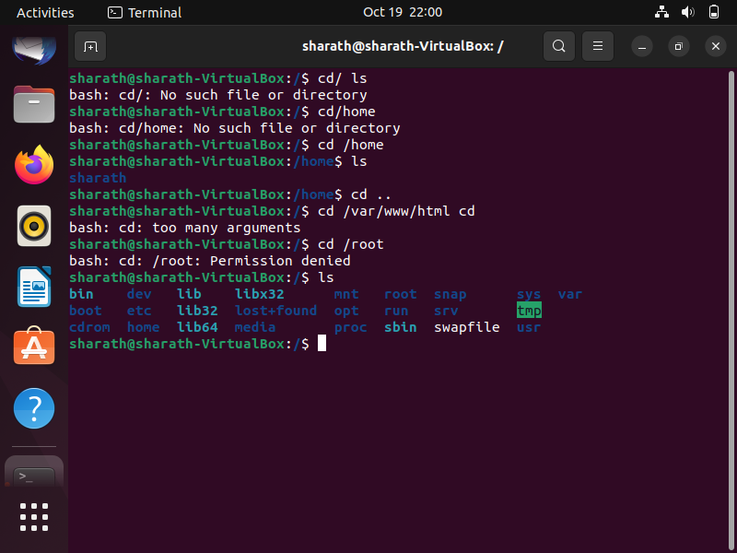

Assignment-4

After typing the cd /etc command the directory changed to the etc file and the directory after using ls command It will list the files present in it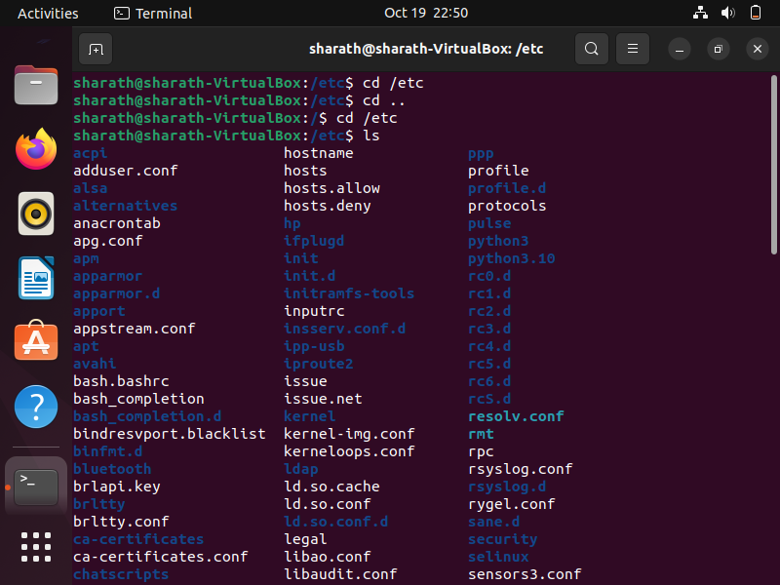

After typing ls-al command it shows the hidden files to see the hidden files the ls-al command is used in linux

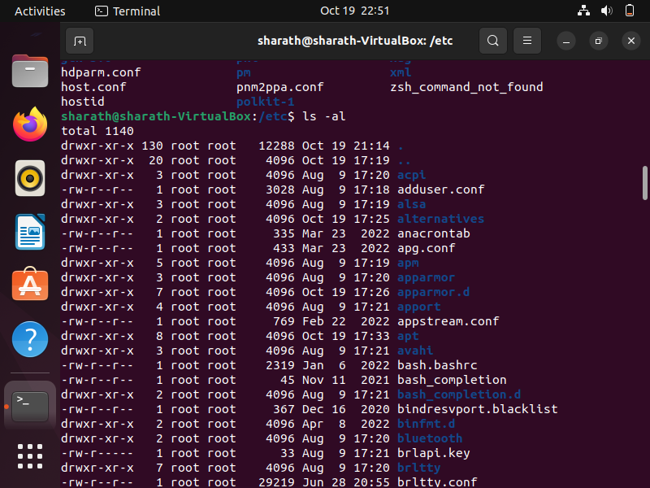

The ls-I command in the linux lists the index inode number 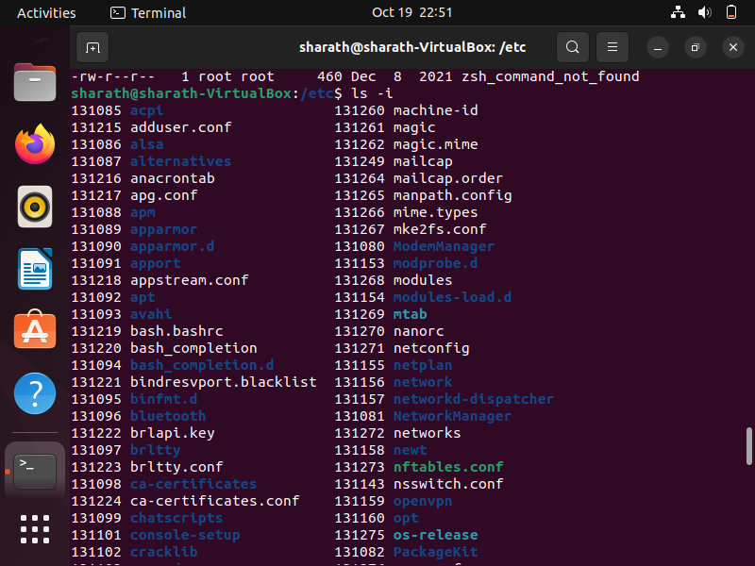

The ls-help and other command options are used in the below

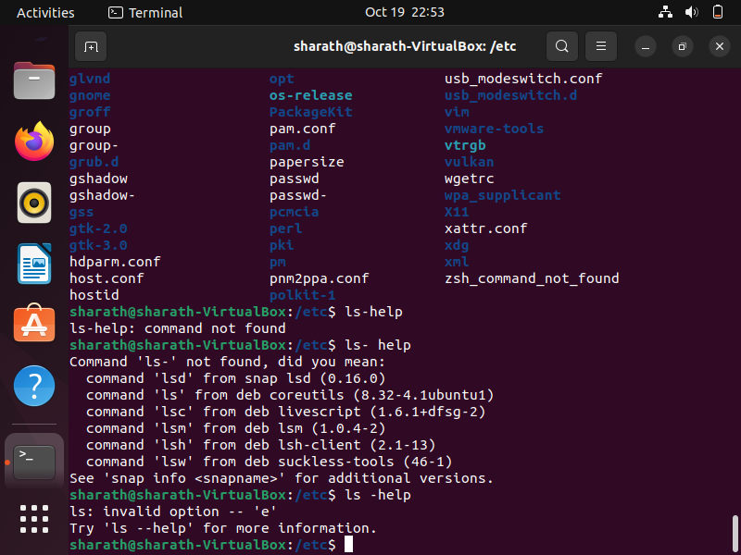

Assignment -5

Here pwd command is used to know the present working directory 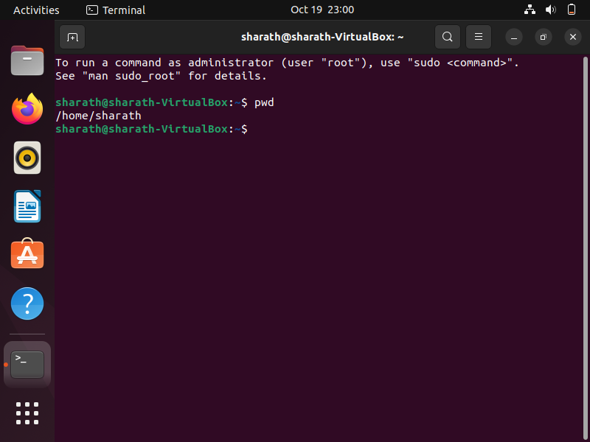

After using cd / var command it changes to the var directory and using ls command it list the files present in the directory 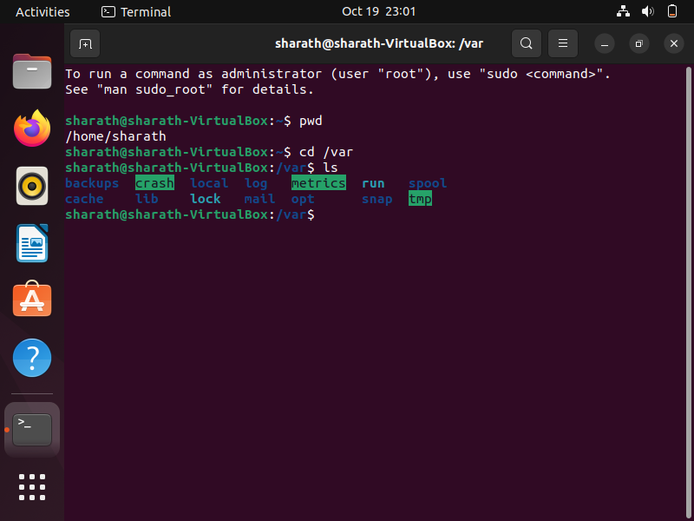

the other help options commands can be used in the linux are ls –d it displays a brief description of the specific command

ls –s display the command syntax of the specified command